Sample Development Appraisal

FOR BORROWERS

Contents

3 - Requirement
4, 5 – Case Overview
6, 7 – Developer Profile
8 - Development Appraisal
9 - Schedule
10 - Planning
11 - Professional Team
12 - Comparable Properties
13 - Assets and Liabilities
14 – Further supporting information
15, 16 – Appendix

Requirement (for lenders)

An 18-month facility of £2,275,000 is sought to enable Globe Results Limited to acquire a site in 10 Kings Road, York, YO1 1ET and undertake the development of 4 new houses with a total of 6000 sq ft.

The loan represents 65% of GDV and 90% of costs.

There will be cash equity of £266,200 in the transaction.

Detailed planning in place at the time of completion.

The build will be undertaken by the developer using sub-contractors known to the developer with an expected budget of £1,175,000 or £195.83 per sq ft (including professional fees).

Repayment will come from sale of units.

(Lender) support will represent 65% of the projected £3.5m GDV

(Lender) support will represent 90% of costs

Case Overview

Ownership

How will you own the new development?
UK Limited Company
Has the company or pension been formed yet?
Yes
What is the Name of the UK Limited Company?
Globe Results Limited
UK Limited Company Number
12322370

Site Details
Address
10 Kings Road, York, YO1 1ET
Will you have planning permission before or on completion of this loan?
Detailed Planning
Do you own the property?
No
Purchase process
Regular Purchase
Planning
Who was responsible for gaining the planning?
Borrower
Please provide any futher information on the planning permission & process
We purchased the site with outline planning 6 months ago, with a bridging loan. We have now dealt with all reserved matters, and have detailed planning permission for 26x 3 & 4 bed houses.
Tell us about how the site will look when the loan completes?
The site will be bare land at completion.

Build procurement
Please tell us about your build procurement
Self-managed procurement (borrowers will manage the individual trade packages)
Please provide us with more information about your chosen procurement method?
We are managing the build ourselves and will tender the individual packages. We have worked this way on 3x previous personal projects. Prior to that one of our shareholders worked as a PM for 10 years at a regional house builder, managing projects of up to 150 houses.

Deposit source
Please tell us what percentage of the total deposit is planned to come directly from the borrowers / named shareholders and how that money is being raised?
50% of the deposit will come from the shareholders and 50% will come from investors. The investors are family and friends and their investment will be secured as a 2nd charge.

Exit strategy
How do you plan to repay the development loan?
Part Sale & Part-Refinance

Completion
Do you have a set completion date for the initial loan?
Yes
Confirmed completion date
02-05-2022
Mezzanine
If mezzanine finance is available for your project, would you like to get quotes?
No
Preferences
Biggest loan Yes - 1
Best pricing Yes - 2
Speed of completion Yes - 4
Great customer service Yes - 3

Existing relationships
Please list the names of any lenders below that you do not wish to be approached to fund this project.
Paragon Bank
Further information
Is there anything else you wish to disclose at this time, positive or negative, that a lender should know before they bid on your project?
No

Shareholders
John Doe
Email Address: john@doe.com
Ownership Percentage: 100%

Developer Profile

How will you own the new development?
UK Limited Company
Are there any lenders that you don't want Brickflow to talk to?
Paragon Bank
Has the company or pension been formed yet?
Yes
Company, pension or partnership name: Globe Results Limited
Company or partnership number: 12322370

Partner Information
Number of partners: 1
Name: John Doe
Email Address: john@doe.com
Date of Birth: 1975-09-02
National Insurance No. WK734588A
Ownership Percentage: 100%
Address: 32 Brookside Road, Istead Rise, Gravesend DA13 9JJ
Years at this address : 2
If less than 3 years , previous address:-
3 Farley Road, Gravesend DA12 2LT
Has the Applicant Developed Property Before? Yes

Shareholder Experience: John Doe
How Many Years has John been a Developer? | 15
Number of Developments John has Completed as an Owner | 7
Number of Residential Projects | 7
Number of Commercial Projects | 0
Years of Experience as an Architect | 0
Years of Experience as a Builder | 0
Years of Experience as a Carpenter | 0
Years of Experience as an Electrician | 0
Years of Experience as an Estate Agency | 0
Years of Experience as a Planner | 0
Years of Experience as a Project Manager | 10
Years of Experience as a Property Surveyor | 0
Years of Experience as a Quantity Surveyor | 0
Years of Experience as a Structural Engineer | 0
Skills | -
Professional Qualifications | BA / BSc

Developer Profile continued: Previous Developments

Development 1
Were you One of the Owners or an Employee? | Owner
Development Type | None
Address Line 1 | 32 Brookside Road
Address Line 2 | Istead Rise
Address Line 3 | Gravesend
Address Line 4 | Kent
Postcode | DA13 9JJ
Acquisition Date | 2016-09-30
Acquisition Costs | £350,000.00
Did you use Developer Finance? | Yes
Development Finance Lender Name | Masthaven
Area Unit | Square Feet
Gross Internal Area sq.m | 3000
Build Costs | £350,000.00
Project Time in Months | 12
GDV | £900,000.00
Sold on Exit | No
Description of Works | Knock down and rebuild of main residence

Development 2
Were you One of the Owners or an Employee? | Owner
Development Type | None
Address Line 1 | 7 Soho Square
Address Line 3 | London
Postcode | W1D 3QB
Acquisition Date | 2018-02-01
Acquisition Costs | £3,500,000.00
Did you use Developer Finance? | Yes
Development Finance Lender Name | Paragon
Area Unit | Square Meters
Gross Internal Area sq.m | 4500
Build Costs | £9,000,000.00
Project Time in Months | 24
GDV | £18,000,000.00
Sold on Exit | No
Description of Works | Office to residential conversion on upper floors, and retention of the downstairs commercial - included a basement dig and 2 storey extension.

Development Appraisal

Property
10 Kings Road, York, YO1 1ET
Property Type: Residential

Area
Acquisition Area (sq.ft):
Build Area (sq.ft): 6,000
Sales Area (sq.ft): 6000
Sales Area / GIA (Commercial, sq.ft): 0

Costs
Purchase Costs
Purchase Price | £1,000,000.00
SDLT | £0.00
Agent Fees | £0.00
Legal Fees | £0.00
Other Fees | £100,000.00
Total Original Purchase Costs | £1,100,000.00
Do you own the property | No

Build Costs
Build Costs | £1,000,000.00
Contingency | £75,000.00
Professional Costs & Charges | £100,000.00
Total Build Costs | £1,175,000.00

Sales & Costs
GDV | £3,500,000.00
Marketing Costs | £ 10,000.00
Agent Fees | £ 35,000.00
Legal Fees | £ 10,000.00
Total Sales Costs | £ 55,000.00
NDV | £3,445,000.00
Summary
Purchase Price | £1,000,000.00
Total Build Costs | £1,175,000.00
GDV | £3,500,000.00
Loan Term Requested (months) | 18
Build Term (months) | 12

Schedule
Houses
Plot Number | Description | Bedrooms | Bathrooms | Area (sq.ft) | Tenure | Sales Price
1 | Detached house | 4 | 3 | 1,800 | Freehold | £1,000,000.00
2 | Semi-detached house | 3 | 2 | 1,200 | Freehold | £ 750,000.00
3 | Semi-detached house | 3 | 2 | 1,200 | Freehold | £ 750,000.00
4 | Detached house | 4 | 3 | 1,800 | Freehold | £1,000,000.00
 |  |  | TOTAL | 6,000 |  | £3,500,000.00

GDVs
Commercial GDV | House GDV | Flats GDV | Parking GDV | Total GDV
£0.00 | £3,500,000.00 | £0.00 | £0.00 | £3,500,000.00

Planning

Link to planning decision notice or Planning application
https://publicaccess.tameside.gov.uk/online-applications/simpleSearchResults.do?action=firstPage

Planning description
We purchased the site with outline planning 6 months ago, with a bridging loan. We have now dealt with all reserved matters, and have detailed planning permission for 4 x 3 & 4 bed houses.

Professional Team

Team Role | Name | Email | Website | Worked With Before | Previous Projects
Architect | Jane Doe | jane@jdarchitects.com | https://janedoearchitects.com | Yes | Worked with them on our project in Soho Square
Main Contractor | JS Build & Design | john@jsdandb.com | https://jsbuildanddesign.com | Yes | Project on Soho Square
Structural Engineer | R Charles | info@rcharles.com | http://www.rcharles.com/ | Yes | Project in Soho Square

COMPARABLE PROPERTIES
Example 1
Property Type: 4 bed detached house
URL: https://www.rightmove.co.uk/properties/118409864#/?channel=RES_BUY
Value: £1,100,000.00
Is this a good comparable? Yes
Why is this a good/bad comparable: It is a very similar spec and layout to our property and is in the same side of the road - south-facing

Example 2
Property Type: 4 bed detached house
URL: https://www.rightmove.co.uk/properties/119098043#/?channel=RES_BUY
Value: £1,150,000.00
Is this a good comparable? Yes
Why is this a good/bad comparable: Similar property - different street

Assets and Liabilities – John Doe

Assets
Property Assets
Residential Properties
32 Brookside Road | £900,000.00
Buy to let (BTL) Properties
10 Brookside Road | £850,000.00
95 Flowerhill Way | £600,000.00
Commercial Properties
1 King Street, York | £2,300,000.00
Overseas Properties | £0
TOTAL | £4,650,000.00

Other Assets
Cash/Deposits
Savings | £1,000,000.00
Stocks & Shares
Barclays bank | £450,000.00
Business equipment, vehicles, art, other | £0
TOTAL | £1,450,000.00
TOTAL ASSETS | £6,100,000.00

Liabilities
Property Liabilities
Address | Value
Residential Property Loans
32 Brookside | £250,000.00
TOTAL | £250,000.00
Other Liabilities
Leasing, overdraft, other loans | £0.00
TOTAL | £0.00

TOTAL LIABILITIES | £250,000.00

NET ASSETS | £5,850,000.00

Outstanding Personal Guarantees
Lender | PG Amount Outstanding | Start Date | Expected End Date
Paragon | £400,000.00 | 2021-12-01 | 2023-03-31
Total Outstanding Personal Guarantees | £400,000.00

Further supporting information
Contact details for site access | Selling agents :- Carter Jonas York office  82 Micklegate York YO1 6LF. 01904 558200
Nationality | British
If not UK national – visa status | N/A
If not UK national – years in UK | N/A
UK resident | YES
Bank Details - Company | Metro Bank  One Southampton Row, London WC1B 5HA  Sort Code 23-05-80  Account no. 33742813
Bank Details - Personal | Barclays Bank  Enfield Town  Sort Code 20-29-77  Account no. 90346139
Solicitor’s details | - John Nelmes – Fieldfisher solicitors  - Riverbank House, 2 Swan Lane, London EC4R 3TT  - john.nelmes@fieldfisher.com  - 0330460 6885
Accountant’s details | - Kevin Hayman – King & Taylor Accountants  - Joynes House, New Road, Gravesend DA11 0AT  - 01474 569777

Appendix
Image of Property
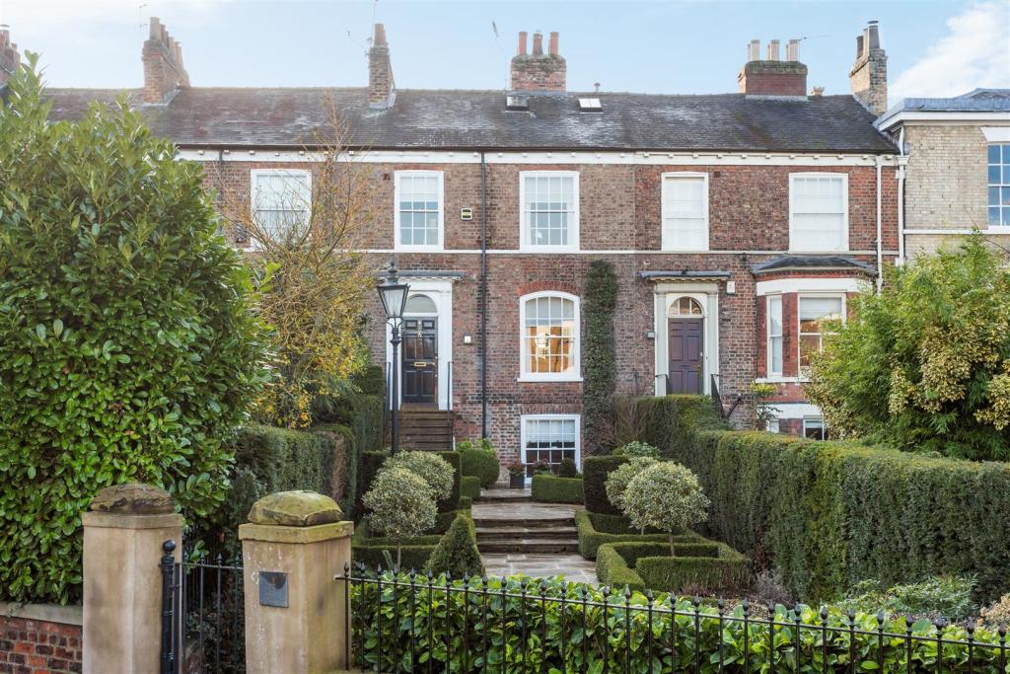

Location area of property – Google Maps

